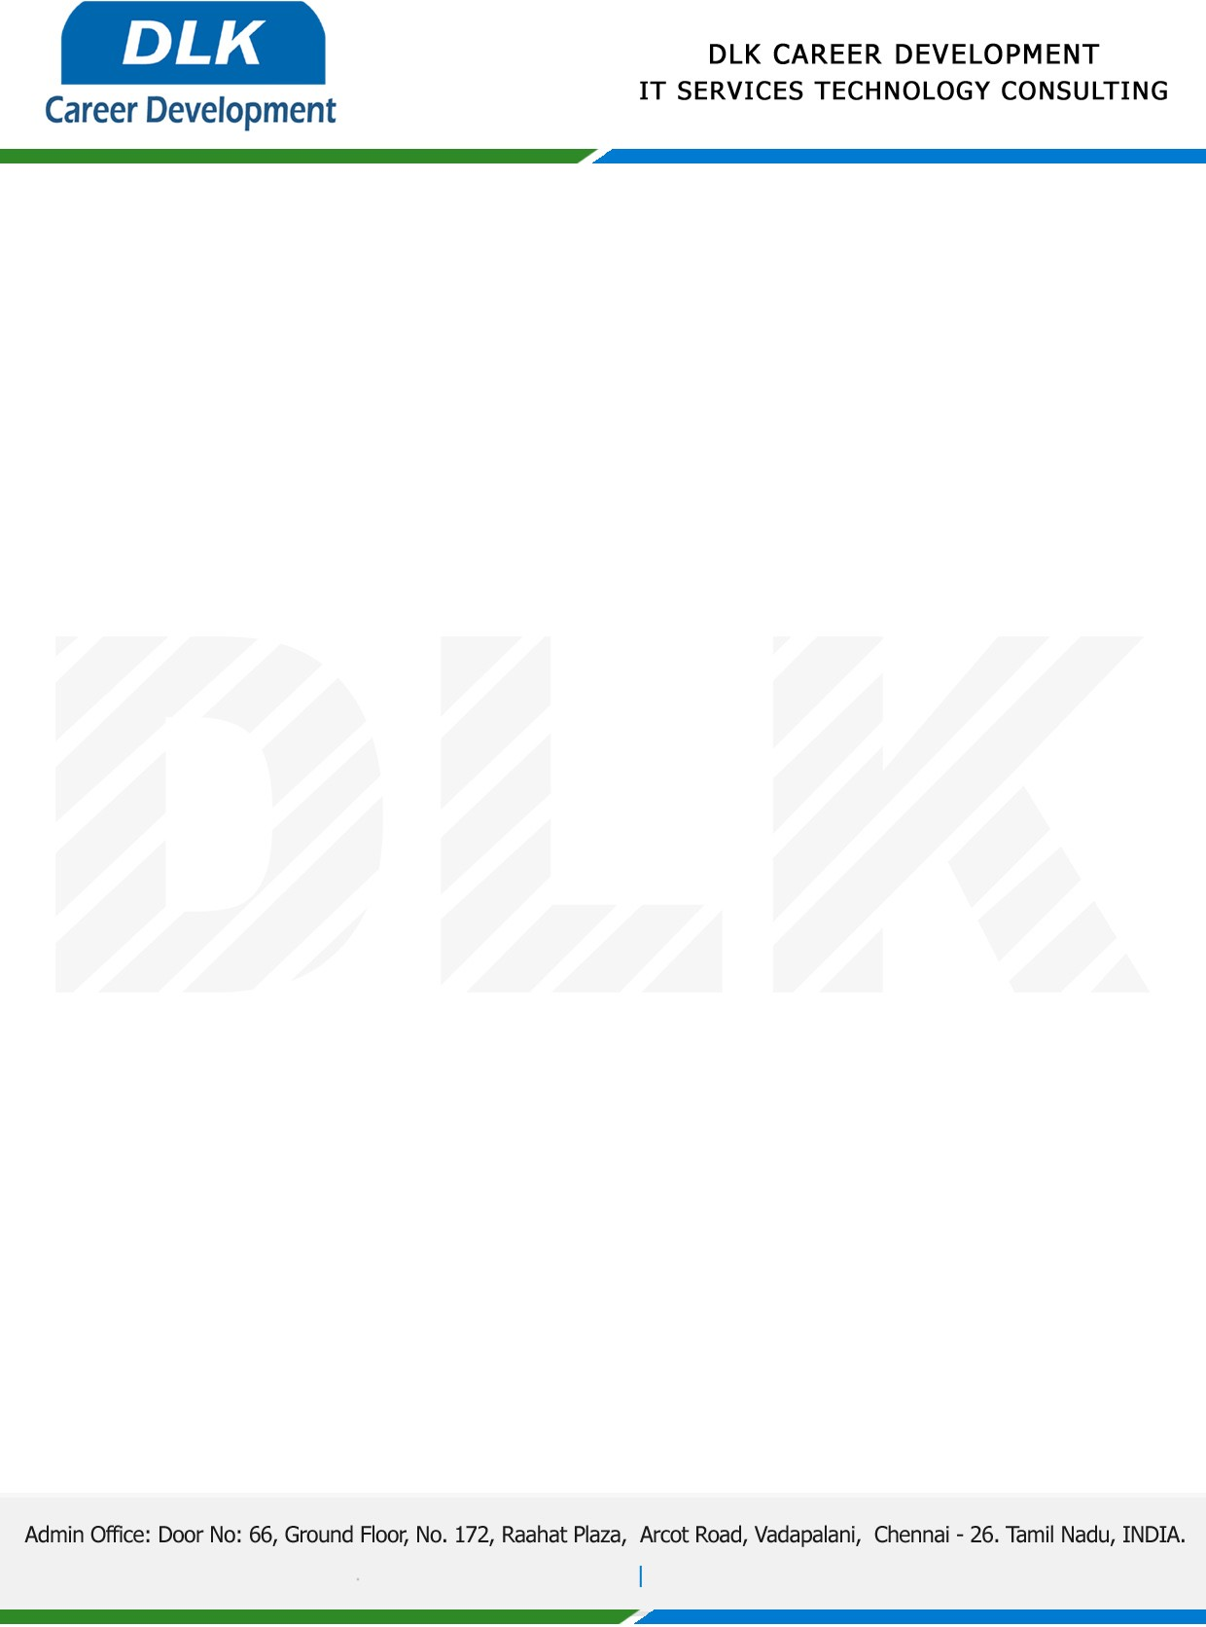

**Date: 19/ April /2023**

**SUB: PROJECT COMPLETION CERTIFICATE**

This is to certify that **MS SAHAYA JENIFFA J (REG NO:** **212004110) BCA- Computer Application,** final year student **Shri Krishnaswamy College for Women, Chennai** has Successfully Completed the Project Work under the domain of “**Java”** in our organization during the Period **(05th January 2023 to 07th April 2023).**

**Topic:** College Bus Management System.

We appreciate your interest in **DLK CAREER DEVELOPMENT**

**“Best Wishes for Your Future Endeavors “**

